Wimbledon mobile mechanic is offering coverage of South-west London for further information pleas contact us
Some of the areas we cover include:
- Wimbledon  - Wandsworth  - Kingston  - Ham  - Morden  - Putney  - Chelsea  - Fullham  - Richmond  - Stratham  - Balham  - Clapham | 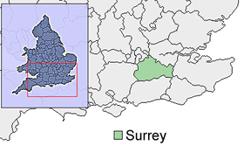

If you fall slightly outside of our coverage area please do contact us to see if we can still assist you with any queries.

